A+ Computer Science STARFIGHTER – GAME PROJECT Lab Value - 100

Lab Goal : This lab was designed to teach you more about OOP and using Abstract Classes and Interfaces.

Lab Description : Write a first person shooter game. You are the StarFighter and your job is to destroy all of the enemies that enter your space. The StarFighter ship and enemy ships will share lots of the same properties. This lab provides the perfect opportunity to use inheritance, abstract classes, and interfaces. You will also review ifs, loops, and ArrayList / Matrices.

Task Four – Extend the MovingThing class to make the Alien class.
Task Five – Add two Aliens to the OuterSpace class. Do NOT use an ArrayList or Matrix to start. This will be added in later. Test the Alien class to make sure all method work. Aliens movement can be determined later. Aliens may move side to side as well as moving down as the game progresses.

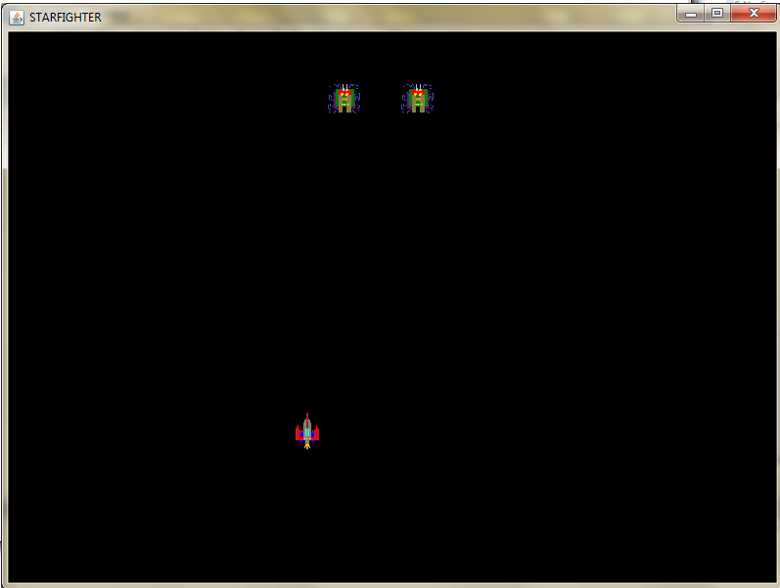
KEYS TO CONTROL THE SHIP

h - left
j - right
u - up
n - down

